**Industrial Internship Report**

**Study on Telecommunication Network and Services with Growing Need of Smart Grid Technology**

*By*

Ravi Ranjan

BTECH/10162/21



Electronics and Communication Engineering

**Birla Institute of Technology, Mesra Ranchi, Jharkhand-835215**

**APPROVAL OF THE MENTOR**

Recommended that the B. Tech. Summer Training Project titled **Study on Telecommunication Network and Services with Growing Need of Smart Grid Technology** submitted by **Ravi Ranjan (BTECH/10162/21)** is approved by me for submission. To the best of my knowledge, the report represents work carried out by the student in **Power Grid Corporation of India Limited** and the content of this report does not form a basis for the award of any previous degree to anyone else.

**Date: Dr A.K Tiwary**

**Assistant Professor**

**Department of Electronics & Communication Engineering**

**Birla Institute of Technology, Mesra**

**DECLARATION CERTIFICATE**

I certify that,

1. The work contained in the report is original and has been done by myself under the general supervision of my supervisor.
2. The work has not been submitted to any other Institute for any other degree or diploma.
3. I have followed the guidelines provided by the Institute in writing the report.
4. I have conformed to the norms and guidelines given in the Ethical Code of Conduct of the Institute.
5. Whenever I have used materials (data, theoretical analysis, and text) from other sources, I have given due credit to them by citing them in the text of the report and giving their details in the references.
6. Whenever I have quoted written materials from other sources, I have put them under quotation marks and given due credit to the sources by citing them and giving required details in the references.

**Date: Ravi Ranjan**

**BTECH/10162/21**

**Department of Electronics & Communication Engineering**

**Birla Institute of Technology, Mesra**

**CERTIFICATE OF APPROVAL**

This is to certify that the work embodied in this Summer Training Report entitled:

“Study on Telecommunication Network and Services with Growing Need of Smart Grid Technology” is carried out by Ravi Ranjan (BTECH/10162/21) has been approved in Electronics and Communication Engineering of Birla Institute of Technology, Mesra, Ranchi.

Date:

Place:

(Industry Mentor) (Institute Mentor) (Panel Coordinator)

Sh. Rakesh Raushan Dr. A.K Tiwary Dr. A.K Tiwary

Ch. Manager, Telecom Asst. Professor Asst. Professor

ER-I, PGCIL Dept. Of ECE Dept. Of ECE

(Head of The Department)

Dr. Sanjay Kumar

Asst. Professor

Dept. Of ECE

#### ABSTRACT

I completed 6 weeks long internship from 17th June 2024 to 31st July 2024 at Regional Headquarter ER-I, Power Grid Corporation of India Limited where I worked as part of the Telecom team.

My main project was to understand how the telecommunication network is spread globally with the help of overhead optic fiber network. I also got an idea about the services provided by telecom and its large base of customers. I had to understand all the methodologies used for making the telecommunication successful. I also got the opportunity to visit various sites and get my hands on some real time problems. I learnt about the splicing of fiber used for restoration of the fiber link in case of cut or failure. I learnt about the optical fiber communication, device and technologies used. Advancement in technologies has resulted in better control and coordination of all the substations and ensure on-site and remote monitoring.

I learnt about some of the modern techniques used at RTAMC for remote monitoring and supervision. SCADA system helps in the controlling all the substations from the regional centre. I also learnt about how the UNMS and ULDC helps RTAMC to fetch all the data and monitor the devices. Cygnet UNMS technology is used for monitoring of the network of the fiber.

I also learnt about how the future of generation, transmission, distribution of power will change significantly with the help of smart grid technology. Smart grid technology will boost the overall development in the Grid. Smart Grid knowledge centre is also established at Powergrid for introducing the changes in small stages.

#### ACKNOWLEDGEMENT

I would like to express our sincere gratitude to the distinguished team members of Telecom department for their steadfast support and direction during this project. Their knowledge, support, and priceless ideas have been crucial in guiding our research projects and improving our techniques.

I would especially like to thank my Industry mentor Sh. Rakesh Raushan, Chief Manager Telecom at ER-I PGCIL, for his excellent guidance and unwavering commitment to my training. His extensive knowledge, unwavering support, and helpful criticism have been essential in guiding us toward achievement. Through his mentoring, we have gained a deeper comprehension of the subject and have been motivated to pursue academic achievement.

I also want to express our sincere gratitude to Mr. Akash Kumar Singh, Junior Engineer at ER-1 PGCIL for giving me the extra support needed during my training. Mr. Singh’s excellence on the subject helped me gain some practical knowledge of the devices and technologies. A supportive learning environment have all been crucial in supporting our efforts and creating a climate that is favorable to creativity and inquiry.

I would also like to thank Dr. AK Tiwary, an assistant professor at BIT Mesra in Ranchi, for his excellent guidance throughout my training. His continuous support motivated me towards my training and helped me in creating my report.

I sincerely thank all of the team members who have worked together to support my academic and research endeavors at PGCIL. I am truly appreciative of their consistent support and encouragement, which have been crucial to our professional and intellectual growth.

Date: (Signature)

Ravi Ranjan

BTECH/10162/21

#### CONTENTS

Birla Institute of Technology, Mesra Ranchi, Jharkhand-835215 1

**APPROVAL OF THE MENTOR** 2

**DECLARATION CERTIFICATE** 3

**CERTIFICATE OF APPROVAL** 4

ABSTRACT 5

ACKNOWLEDGEMENT 6

CONTENTS 7

LIST OF FIGURES 9

LIST OF TABLES 10

1. INTRODUCTION 11

1.1 Company Overview [1] 12

1.1.1 PowerTel's Telecom Licenses and Registrations: - 12

1.1.2 Presence in transmission: - 12

1.1.3 Venture into Telecom Business: - 12

1.1.4 Main Technology deployed in POWERGRID’s Telecom:- 12

1.2 Project Scope 13

1.3 Objectives 13

2. TELECOMMUNICATION NETWORK AND SERVICES 14

2.1 Telecommunication Network [2] 14

2.2 Telecom Services [2] 14

2.2.1 Lease Lines (Point to Point Lease Line) 14

2.2.2 MPLS-VPN Services 15

2.2.3 Data Services 15

2.2.4 Infrastructure Services 15

2.2.5 Data Centre Services 15

2.2.6 International Long Distance Services 15

2.2.7 Other Upcoming Services 15

3. METHODOLOGY 16

3.1 Optical Fiber Communication 16

3.1.1 SINGLE MODE 16

3.1.2 MULTIMODE 17

3.2 Devices Used for Telecommunication. 17

3.2.1 Optic Fiber 17

3.2.2 Patch Cords and LAN Cables 18

3.2.3 Small Form-Factor Pluggable 19

3.2.4 Power Meter 20

3.2.5 Splicing Machine 21

3.2.6 Optical Time Domain Reflectometer (OTDR) 22

3.2.7 Optical Ground Wire – OPGW 22

3.2.8 0db and Attenuators: - 23

3.2.9 Media Converter 23

3.2.10 FODP (Fiber Optic Distribution Panel) 23

3.2.11 Rectifier 24

3.2.12 VRLA Batteries 24

3.3 Technologies Implemented 24

3.3.1 OPGW - Optical Fibre Ground Wire over high voltage Transmission line 24

3.3.2 MPLS - Multi Protocol Label Switching 25

3.3.3 SD-WAN - Software Defined Wide Area Network 26

3.3.4 DDoS - Distributed Denial of Service 26

3.3.5 DWDM - Dense Wave Division Multiplexing 26

3.3.6 SDH - Synchronous Digital Hierarchy 27

3.3.7 UTM - Unified Threat Management 28

4. LEARNINGS AND CHALLENGES 29

4.1 On- Site Experiences 29

4.2 UNMS 32

4.2.1 Cygnet UNMS [12] 32

4.2.2 UNMS Server Room Architecture 33

4.2.3 Network Topology 34

4.3 NTAMC and RTAMC 35

4.3.1 FUNCTIONS OF NTAMC 36

4.3.2 BENEFITS OF NTAMC SYSTEM 37

4.4 SCADA [10] 37

4.4.1 Components of a SCADA System in Telecommunications: Hardware and Software 38

4.4.2 Benefits of SCADA in Telecommunications: Enhancing Network Performance and Security 38

4.4.3 Implementation of SCADA in Telecommunications: Best Practices and Strategies 39

5. SMART GRID AND THE FUTURE 40

5.1 Smart Grid Technology [11] 40

5.1.1 Advanced Metering Infrastructure 40

5.1.2 Demand Response 40

5.1.3 Electric Vehicles (EVs) 41

5.1.4 Wide-Area Situational Awareness 41

5.1.5 Distributed Energy Resources and Storage 42

5.1.6 Distribution Grid Management 42

5.2 Smart Grid Knowledge Centre 42

5.2.1 Advanced Measurement Infrastructure [13] 44

5.2.2 Idle Call/Outage Management System [14] 44

5.2.3 AC Micro-Grid [18] 44

5.2.4 Smart Home/Home Energy Management System [15] 44

5.2.5 Direct Current/DC Micro Grid [16] 45

5.2.6 Power Quality [17] 45

6. REFERENCES 46

#### LIST OF FIGURES

Figure 1.0.1 Regional Headquarter ER-I PGCIL 11

Figure 2.1 Transmission line Tower with OPGW [4] 14

Figure 3.1 Basic Operation Of Optical Fiber [3] 16

Figure 3.2 Single Mode and Multimode fiber [5] 17

Figure 3.3 a) Optical Fiber b) Closure Box for spliced fiber 18

Figure 3.4 a) SC-SC b) LC-LC c) SC-LC d) SC-FC e) LC-FC f) LAN Cable g) Console Cable 19

Figure 3.5 a) ACTIVE COPPER SFP b) STM-1 155M 20

Figure 3.6 a) Cutting of an Optical Fiber b) Sharpening of the edges c) Fusion of the core 21

Figure 3.7 a) Location of the fault b) OTDR display of fiber with no loss 22

Figure 3.8 a) Internal Structure of an OPGW [8] b) Splice Box or Joint box. 23

Figure 3.9 Transmission Line with Overhead Optic fiber network [4] 25

Figure 4.1 a) Telecom Server Room b) VRLA Batteries c) Intelligence Cell At CRPF, Patna, Bihar d) Fiber Splicing of KRIBHKO-Bihar Grid link e) Closure Box for Spliced fiber 29

Figure 4.2 a) UNMS Monitoring Room b) UNMS Server room c) SMAC Chamber at ATS Headquarters Patna d) RTAMC ER-1 PGCIL Patna 30

Figure 4.3 NIC Site a) National Knowledge Network Centre b) NIC Monitoring Room c) PGCIL racks at NIC (SDH) d) Routers and Devices 31

Figure 4.4 UNMS Monitoring Room at PGCIL ER-1 32

Figure 4.5 DR Server Room Architecture 34

Figure 4.6 Server Rack Main b) Network Rack (Main) 34

Figure 4.7 Network Topology view of ER-I and ER-II 35

Figure 4.8 Network Topology View of RHQ 35

Figure 4.9 RTAMC ER-I PGCIL 36

Figure 4.10 Power Map of Eastern Region 37

Figure 5.1 a) Advanced Measurement Infrastructure Lab PowerGrid [19] b) Idle Call/ Outage Management System [20] c) AC Micro-Grid [21]d) Smart Home [22] e) DC Hut [23] f) Power Quality test [24] 43

#### LIST OF TABLES

|  |  |  |
| --- | --- | --- |
| Table 3.1 | Color Code of Optic Fiber | 20 |
| Table 3.2 | Line Hierarchy of SDH | 30 |

***CHAPTER 1***

# 1. INTRODUCTION

The purpose of my internship was to gain practical experience in the field of telecommunication, and to apply the concepts and techniques of OFC. OFC is a methodology that is used in telecom industry for transmitting information from one station to another. Single mode fiber is used in telecom for transmitting to cover longer distances with minimum loss of data. Electricity network topology formed the Optic fibre backbone network

PGCIL is a Schedule ‘A’, ‘Maharatna’ Public Sector Enterprise of Govt of India. PowerTel a 100% wholly owned subsidiary of POWERGRID, only telecom service provider in the country having a PAN India overhead optic fiber network on Extra High Voltage Transmission Lines. POWERGRID offers various telecom services, such as Lease Lines (Point to Point Lease Line), MPLS-VPN Services, Data Services, Infrastructure Services, Data Centre Services, International LongDistance Services and Other Upcoming Services like Video Conferencing, Communication Services, VOIP Wi-Fi, Consultancy ICT for Smart Cities.

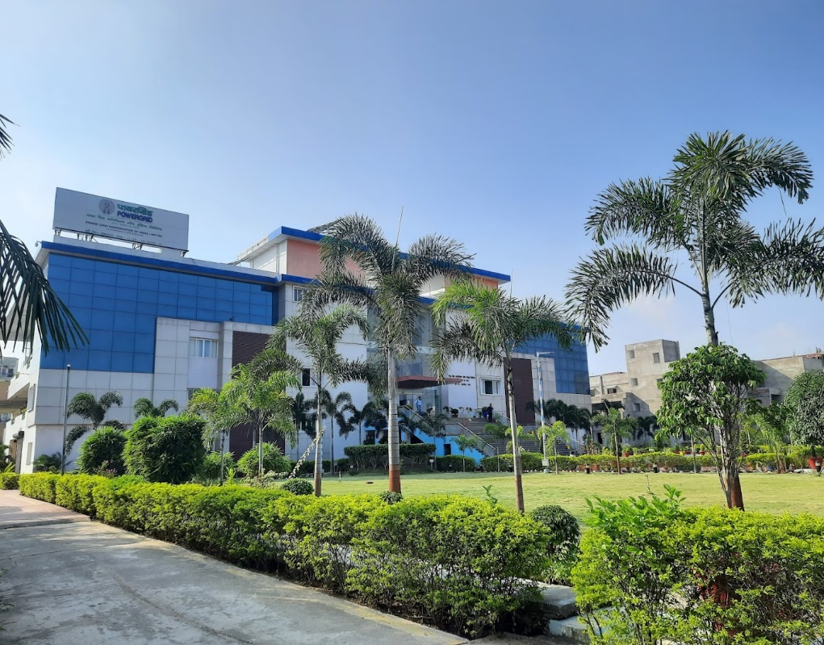

Figure 1.0.1 Regional Headquarter ER-I PGCIL

## Company Overview [1]

POWERGRID with its brand name ‘POWERTEL’ in Telecom business is the only Telecom Service Provider in the country having pan India overhead Optic fiber network using Optical Ground Wire on power transmission lines and is offering transmission towers for Mobile Communications.

* More than 1,00,000 km of Network
* More than 3000 Nos. locations connected
* Backbone Equipment capacities in Tbps
* Intra-City Network Network in 256 Cities

### PowerTel's Telecom Licenses and Registrations: -

1) National Long-Distance (NLD)

2) Internet Service Provider Category-A (ISP-A)

3) Infrastructure Provider-I (IP-I) Registration

### Presence in transmission: -

Electricity network topology formed the Optic fibre backbone network. Power transmission lines, criss-crossing the entire length and breadth of the country connecting the major metropolitan cities/towns, provide an excellent infrastructure for stringing optical fibre cable which can be used to set up a high-grade long-distance telecommunication network of high capacity

### Venture into Telecom Business: -

POWERGRID has been entrusted with the responsibility of implementation of System Coordination and Control (SC&C) projects in various regions for better overall coordination and effective management of interconnected grid networks.

For real time monitoring, better management of grid through state-of-the-art Supervisory Control and Data Acquisition (SCADA) & Energy Management System (EMS) technologies, require dedicated wideband communication networks.

### Main Technology deployed in POWERGRID’s Telecom:-

❖ OPGW - Optical Fibre Ground Wire over high voltage Transmission line

❖ MPLS - Multi Protocol Label Switching

❖ SD-WAN - Software Defined Wide Area Network

❖ DDoS - Distributed Denial of Service

❖ DWDM - Dense Wave Division Multiplexing

❖ SDH - Synchronous Digital Hierarchy

❖ UTM - Unified Threat Management

## Project Scope

The main scope of my internship was to learn and implement the technologies used in the telecommunication. Understanding of various technologies that help in practical application and problem solving of reallife problems. A brief knowledge of the devices used in the telecommunication network. Implementation of various techniques for better understanding of the telecom network. Analysing the previously laid grid network of transmission line and using it for developing the telecom network. I also got an experience with the daily life problems faced in the telecom department. Understanding of SAP for dealing with the vendors and customers for billing and documentation of the data online. Understanding of the diagram and layout of the fiber at different places in Patna. Analysing the backbone connectivity in Bihar and brief knowledge of the substations. Learnt about the configuration of the router used at different substations for communicating with the headquarter. Get a briefing of SCADA, UNMS, ULDC etc that helps RTAMC in remote monitoring of substations.

## Objectives

The objectives I aimed to achieve during the internship were:

* To learn about the Optical fiber communication (OFC) and its use in telecommunication network.
* To get an overview of telecommunication network and services.
* To learn about the OPGW and other devices used in the network.
* To get the concepts of technologies used.
* To understand the SCADA system used at RTAMC.
* To learn about the smart grid technology and its future objectives.

***CHAPTER 2***

# Telecommunication Network and Services

## Telecommunication Network [2]

With an extra high voltage transmission line PAN India overhead optic fiber network, Powergrid is the only telecom service provider in the nation. Its communication network spans over one million kilometers throughout all of India. In all, it has connected to almost 3000 places. The capacity of backbone equipment are expressed in Tbps. In 256 cities, it has established an intra-city network.

The telecom sector has a wide client base of extremely happy clients and offers a wide range of services. A collection of nodes connected by communication lines that allow the nodes to exchange messages is known as a telecommunications network. High availability of the overhead transmission line network utilizing OPGW.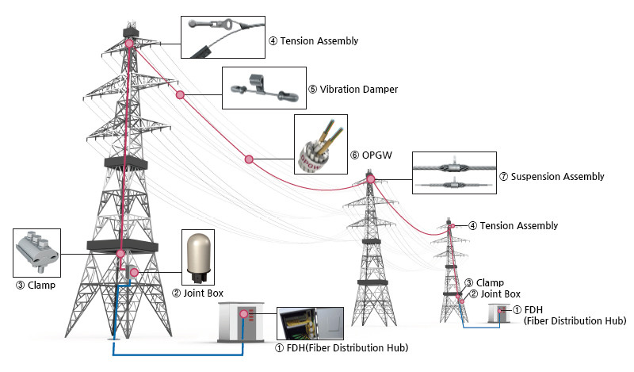

Figure 2.1 Transmission line Tower with OPGW [4]

## Telecom Services [2]

### Lease Lines (Point to Point Lease Line)

* SDH/DWDM
* Port Capacity up to 100 Gbps
* Backbone Network Capacity in multiple Tbps
* Backbone Network Reliability of >99.5%
* Multiple self-resilient rings for complete redundancy in backbone as well as intra city access networks

### MPLS-VPN Services

* Three tier architecture with Core, Edge and Access layers
* Dual Home connectivity to avoid Single point of failure in backbone
* Network is designed to cater to real time applications
* Layer-2 & Layer-3 VPN technologies to serve all type of connectivity requirements and different Class of Service
* Network is scalable to 500 Gbps in core
* Physically Segregated Internet Network for Security of VPN Network & SDWAN

### Data Services

* Internet (1:1) symmetric
* IP transit
* SDWAN/DDoS/DNS

### Infrastructure Services

* Dark Fiber on UGOFC
* Tower Space for BTS & fiber connectivity with uninterrupted Green Renewable Power

### Data Centre Services

* Existing 100 Racks Data Centre for In-House Usage
* Building 1000 Racks Data Centre in Northern India
* Building 500 Racks Disaster Recovery Centre in Southern India

### International Long Distance Services

* IPLC Circuit to Nepal and Bangladesh

### Other Upcoming Services

* Video Conferencing
* Communication Services
* VOIP
* Wi-Fi

***CHAPTER 3***

# Methodology

I understood the concepts of OFC used for telecommunication. I got a brief knowledge about the devices and technologies used. Understood the symbols used in fibre layout diagram and learnt to draw the diagrams. I also got opportunity to use a few devices and implement some technologies. Understanding of the backbone connectivity in Bihar. Some onsite experience along with the practical approach of the concepts. Understood about the telecom services and customers.

## 3.1 Optical Fiber Communication

Fiber-optic communication is a technique that uses visible or infrared light pulses sent through an optical fiber to transfer data from one location to another. Information is carried by modulated carrier waves, such as light. The principle of entire reflection is employed in optical communication. Long-distance transmission can be accomplished when light injection angle meets specific requirements and forms entire reflection in the optical fiber.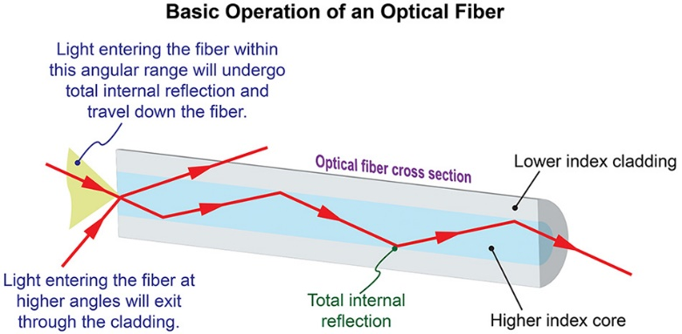

Figure 3.1 Basic Operation Of Optical Fiber [3]

### SINGLE MODE

The lower diameter of the glass fiber core allows single-mode fiber to be used over longer distances. Attenuation, or a drop in signal strength, is less likely with this smaller diameter. A more direct path and a longer signal transmission distance are made possible by the smaller aperture, which concentrates light into a single beam.   
  
Additionally, compared to multimode fiber, single-mode fiber has a far larger bandwidth. A laser is commonly utilized as the light source for single-mode fiber. Due to the precise calculations needed to create laser light in a smaller hole, single-mode fiber is typically more expensive.

### MULTIMODE

Because multimode fiber has a bigger core aperture that allows light signals to bounce and reflect more throughout the path, it is employed for shorter distances. More data may be transmitted across the cable because of its wider diameter, which enables the transmission of numerous light pulses at once. Additionally, there is a greater chance of interference, signal loss, or diminution. An LED is usually used in multimode fiber optics to produce the light pulse.

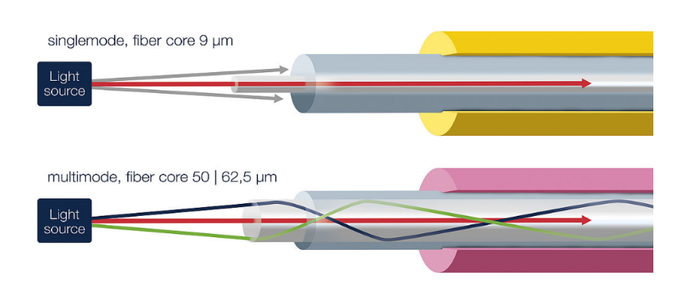

Figure 3.2 Single Mode and Multimode fiber [5]

## Devices Used for Telecommunication.

### Optic Fiber

Information is transmitted as light pulses along a glass or plastic fiber using a method known as fiber optics, or optical fiber.

There are several hundred glass fibers in a fiber optic cable, however the quantity might vary. The glass fiber core is encircled by yet another layer of glass known as cladding. The final layer of protection for each individual strand is a jacket layer, which serves to shield the cladding from damage.

Through the use of a fiber optic cable and pulsating light particles called photons, data is transmitted via fiber optics. Incoming light is bent at a specific angle by the refractive indices of the glass fiber core and the cladding.

Total internal reflection is the method by which light signals traveling through the fiber optic cable bounce back off the core and cladding in a pattern of zigzag bounces. Because of the thick glass layers, light signals move approximately 30% more slowly than light. They do not travel at the speed of light.

Table 3‑1 Color Code of Optic Fiber

|  |  |
| --- | --- |
| **Fiber Number** | **Color** |
| **1** | **Blue** |
| **2** | **Orange** |
| **3** | **Green** |
| **4** | **Brown** |
| **5** | **Slate** |
| **6** | **White** |
| **7** | **Red** |
| **8** | **Black** |
| **9** | **Yellow** |
| **10** | **Violet** |
| **11** | **Rose** |
| **12** | **Aqua** |

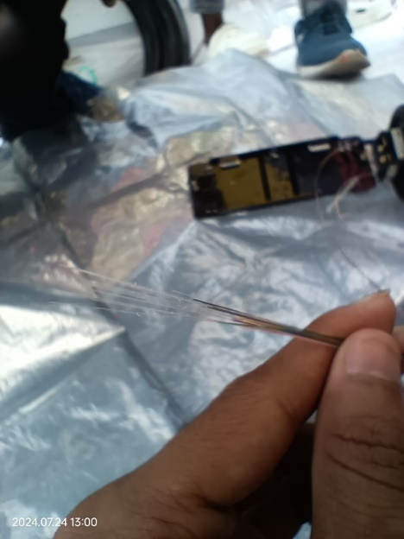

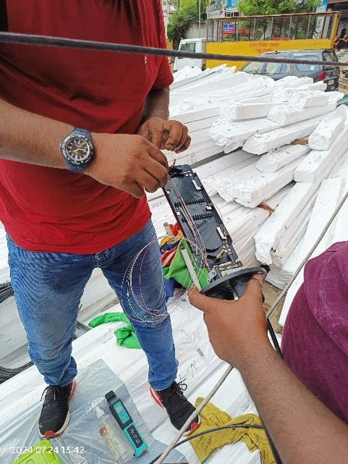

Figure 3.3 a) Optical Fiber b) Closure Box for spliced fiber

### Patch Cords and LAN Cables

An electrical or fiber-optic cable known as a "patch cable," "patch cord," or "patch lead" is used to connect (or "patch in") one electronic or optical device to another for signal routing. Patch cords are used to connect many kinds of devices, such as a switch to a router or a computer.

The ability of patch cords to quickly and easily connect electronic equipment is one of their main benefits. With the help of these cables, devices like computers, switches, routers, and servers may effectively communicate and transport data.

Depending on the connector type, fiber optic patch cords can be categorized as FC, ST, SC, LC, MU, E2000, MTRJ, SMA, MPO/MTP, etc.

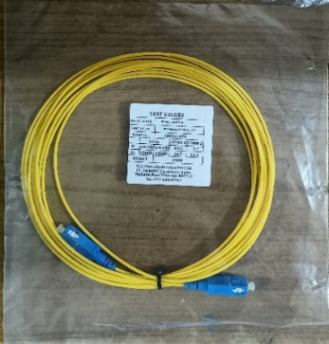 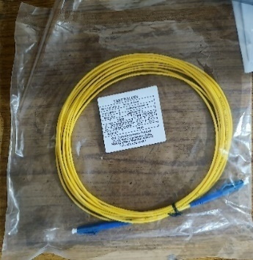 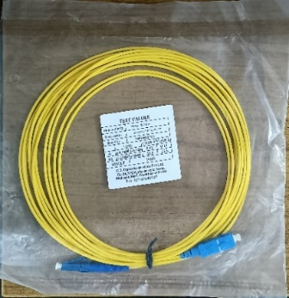 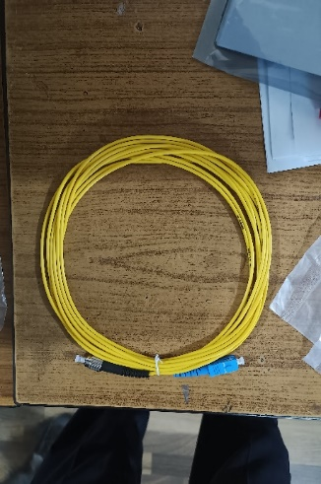

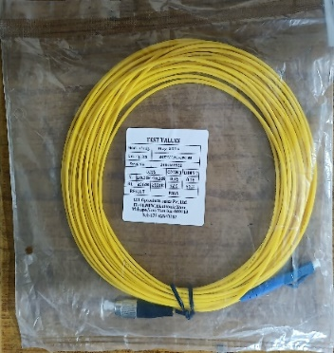 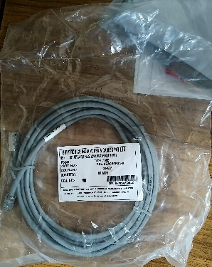 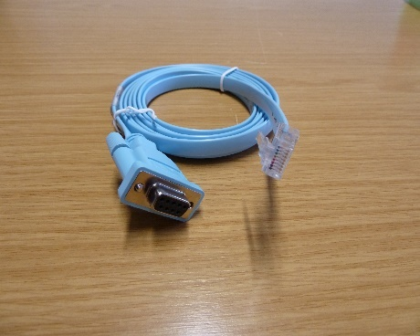

Figure 3.4 a) SC-SC b) LC-LC c) SC-LC d) SC-FC e) LC-FC f) LAN Cable g) Console Cable

### Small Form-Factor Pluggable

A network device or computer slot designated for the insertion of small form-factor pluggable (SFP) transceivers is called an SFP port. SFP transceivers, sometimes called SFP modules, are simply hot-swappable, metal parts the size of a pinky that transmit data through a cable to another device.

It makes it easier to send and receive data by converting Ethernet signals into optical signals with ease.

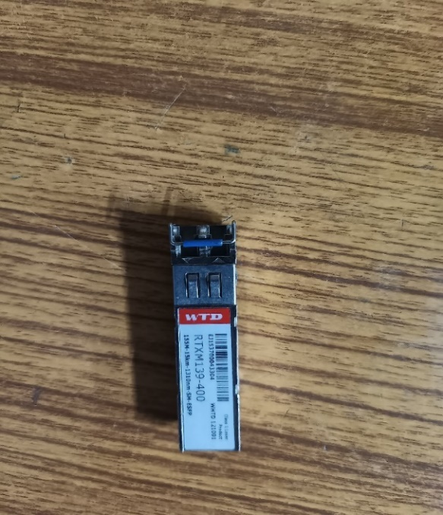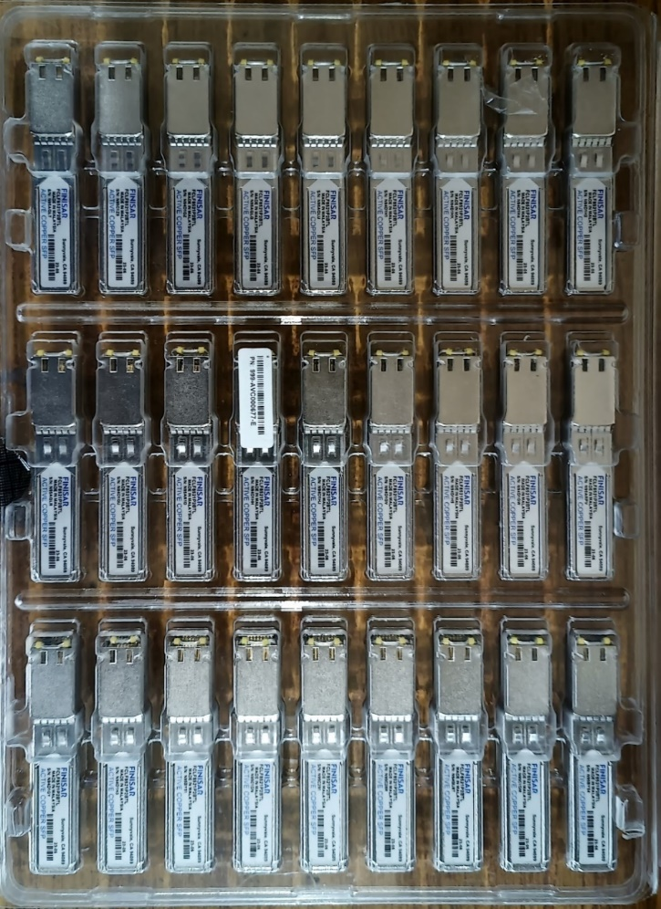There are 4 types of STM (Synchronous Transport Module) in SFP technology used by Power Grid

* + 1. STM 1: 155Mbps

b) STM 4: 622Mbps

c) STM 16: 2.5 Gbps

d) STM 64: 10 Gbps

Figure 3.5 a) ACTIVE COPPER SFP b) STM-1 155M

Small, independent electronic devices called fiber optic SFP modules use optical fiber cables to send and receive light pulses. They are employed in fiber optic communication systems to transform electrical impulses into light pulses so that glass or plastic fibers may carry them over great distances.

Electrical SFPs employ electrical signals, whereas optical SFPs use light to transfer data. Optical SFPs can carry data faster than electrical SFPs because light travels faster than electrical signals. For high-bandwidth applications, optical SFPs are therefore a superior option.

### Power Meter

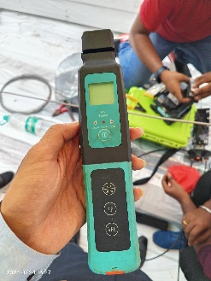

***Optical power meter***

The amount of light leaving the end of the fiber optic cable is measured by a specialized light meter called a fiber optic power meter. The light must be measurable by the power meter at the right power range and at the correct wavelength.

***Clamp meter***

To measure the current flowing through a live wire, a clamp meter can be clamped around it. In order to measure the current value, a clamp meter uses the magnetic field that is produced as current flows through a wire.

WORKING PRINCIPLE: To measure the current value, clamp meters detect the magnetic field that is produced when current flows in a wire.

***Optical Multi Meter***

WORKING PRINCIPLE - When the fiber is exposure to produce the corresponding photocurrent (LASER), namely on the optical detector host part of the role is to detect the signal amplification and D/A transformation into the CPU and the CPU processing digital signal in optical power or power level of the corresponding form display.

### Splicing Machine

An electric arc is used by a fiber optic fusion splicer to fuse two optical fibers at their ends into a single, long fiber. Long optical links are formed using this technology in optical fiber communication to improve long-distance optical signal transfer. In essence, splicers are couplers that join two fibers or fiber bundles together.

There are 2 types of splicing: -

a) Fusion splicing- Here two fiber patch cord are connected by melting two fibers giving it high heat.

b) Mechanical splicing- Here two fiber patch cord are connected using connectors.

The aim is to fuse the two fibers together in a way that is almost as strong as the intact fiber, and in which light traveling through the fibers is neither dispersed or reflected back by the splice.

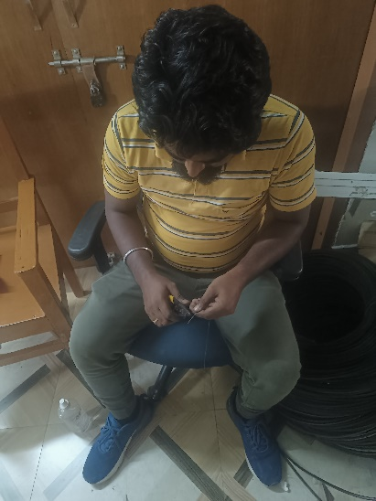 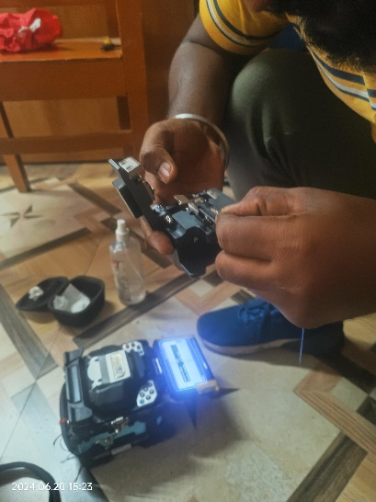 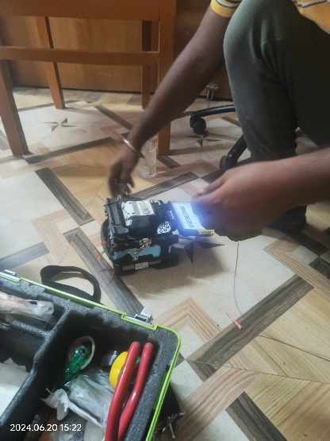

Figure 3.6 a) Cutting of an Optical Fiber b) Sharpening of the edges c) Fusion of the core

### Optical Time Domain Reflectometer (OTDR)

* An optoelectronic device used to characterize an optical fiber is an optical time-domain reflectometer (OTDR). It is the optical counterpart of a time-domain reflectometer that is used to measure the impedance of the test fiber cable.
* FUNCTION: - An OTDR introduces a sequence of optical pulses into the fiber being tested and retrieves light that is reflected or scattered back from various locations along the fiber from the same end of the cable. The optical fiber is characterized by the light that is gathered back, either scattered or reflected. Plotting the return pulse strength as a function of fiber length, the strength is measured and integrated over time.
* Slope of the OTDR shows loss in the fiber. It measures wavelength of 1200nm to 1550nm.
* Loss in OTDR is inversely proportional to wavelength.
* We use patch cords in OTDR to cover dead zones.

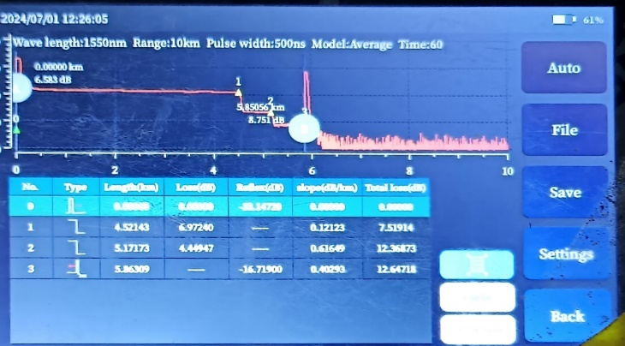 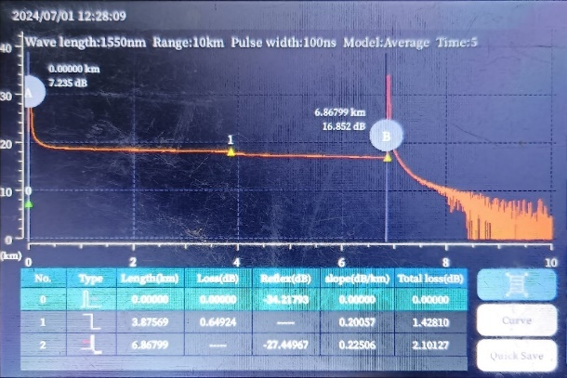

Figure 3.7 a) Location of the fault b) OTDR display of fiber with no loss

### Optical Ground Wire – OPGW

Cables used in overhead electricity lines are known as optical ground wires. It integrates the roles of communication and grounding. A tubular construction with one or more optical fibers within and layers of steel and aluminum wires around it makes up an OPGW cable. The high-voltage electrical pylons' tops are where the OPGW cable is run. The conductive portion of the cable protects the high-voltage conductors from lightning strikes and acts as a link between neighboring towers and the ground.

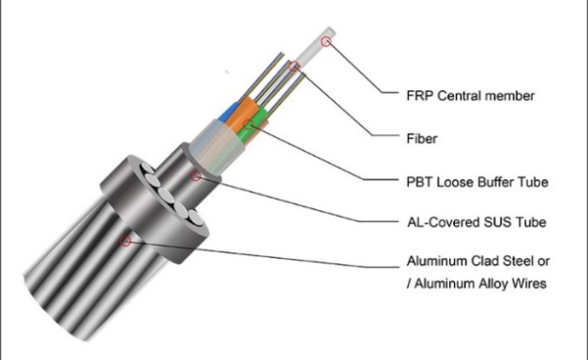 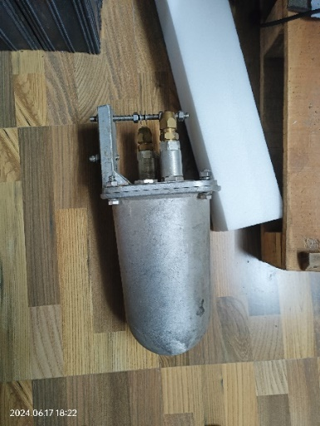

Figure 3.8 a) Internal Structure of an OPGW [8] b) Splice Box or Joint box.

### 0db and Attenuators: -

A device called 0 dB is used to join two patch cords of the FC-FC type. Around 0 Db loss is provided.

Devices called attenuators are used to reduce the power, amplitude, and strength of signals. When viewed via the aperture, the attenuator has an extra ring-like shape that sets it apart from the 0 dB connections.

### Media Converter

A networking device called a media converter joins two different media, such as Ethernet copper and Ethernet fiber. The device's LAN cable is removed and attached to the media converter. The SC patch cord is then stretched and secured on the media converter's TX. Next, this fiber travels to FODP, where the optical signals undergo yet another conversion process to electrical signals before being sent over a second LAN line to the equipment.

### FODP (Fiber Optic Distribution Panel)

The central nervous system of any high-density network is FODP. Within a corporate network, fiber optic cables are arranged and managed using it.

A fixed number of ports are present on a single distribution panel hardware component to connect incoming and outgoing optical cables. Fiber jumper cables are connected from each port to another port that is located elsewhere. These assemblies make it simple to reorganize, fix, or replace circuits inside a network.

### Rectifier

A rectifier is an electrical device that uses one or more P-N junction diodes to change AC power into DC power. Alternating current flows in two directions; it is converted to direct current, which flows in one direction, using a rectifier. What an inverter does is the reverse operation. Rectification is the term for the process since it "straightens" the direction of the current.

### VRLA Batteries

A valve regulated lead-acid battery, or VRLA battery for short, is a kind of lead acid battery that has a relief valve that holds the battery contents in place regardless of the position of the cells, a limited amount of electrolyte ("starved" electrolyte) absorbed in a plate separator or formed into a gel, and the proportioning of the positive and negative plates to facilitate oxygen recombination within the cell. It is a rechargeable battery that doesn't need to be maintained constantly and can be installed in any direction.

They have two working modes:

a) Float: 2.23 V

b) Boost: 2.30 V

## Technologies Implemented

### OPGW - Optical Fibre Ground Wire over high voltage Transmission line

One of the most dependable fiber optic mediums is OPGW, which is utilized by telecom service providers, ISPs, cable TV companies, and other businesses that transmit voice, data, video, text, messages, conferences, and telemetering types of content. In 1980, installation started to spread widely. Globally, about 60,000 km of OPGW were installed in 2000. In addition to meeting their own internal communication demands, many electric utilities are adding high capacity fiber optic cables and wires to their high voltage lines in order to increase revenue by leasing excess capacity to telecommunication network providers. Overhead transmission power line corridors serve the electric utilities by earning additional revenue utilizing existing facilities, while also offering the telecoms industry affordable alternative routes.

Fiber optics offers fixed link, point-to-point communications with an exceptionally high data carrying capacity, which is its intrinsic advantage as a communication technology.

***ADVANTAGES OF OPGW CABLES:***

* Fiber optic communication cables don't interact with electromagnetic signals or produce interference of any kind.
* Electrical insulation can be used to separate system components from aerial fiber optic cables and any associated equipment.
* Without the need for repeaters, the technique provides extremely long information transmission distances of up to 80 km (50 miles).
* With the incredibly high transmission capacity provided by fiber optic technology, information can be transferred at up to three gigabytes per second (Gbps).



Figure 3.9 Transmission Line with Overhead Optic fiber network [4]

### MPLS - Multi Protocol Label Switching

Dedicated pathways can be established across networks using multiprotocol label switching (MPLS), which eliminates the need for the standard routing procedure. a method of routing data in communications networks that uses labels rather than network addresses to determine which node to send data to next. Labels identify established paths between endpoints, while network addresses identify endpoints. a typical technique for building the links between the local area networks (LANs) that comprise wide area networks (WANs). MPLS enhances the standard operation of the Internet by sending packets along predefined network paths via specialized routers.

**Where is MPLS used?**

When a corporation needs access to a data center or applications at the corporate headquarters or another branch location, and it has several remote branch offices spread across the nation or the globe, they frequently utilize this technology.

**TYPES OF MPLS: -**

* Layer 2 point-to-point. Layer 2 point-to-point is a type of MPLS suitable for companies that need high bandwidth connections connecting a few locations together while maintaining cost-effectiveness.
* Layer 2 Virtual Private LAN Services (VPLS) ...
* Layer 3 IP/VPN.

**Why is MPLS required?**

Enhance Uptime: Your network provider will need to perform less manual intervention to establish a WAN, which lowers the possibility that a human error will bring down your circuit. This is accomplished by transmitting data via an alternate way in less than 50 milliseconds (if one exists).

### SD-WAN - Software Defined Wide Area Network

SD-WAN is a software-defined approach to managing the WAN.

Key advantages include:

* Reducing costs with transport independence across MPLS, 4G/5G LTE, and other connection types.
* Improving application performance and increasing agility.
* Optimizing user experience and efficiency for software-as-a-service (SaaS) and public-cloud applications.
* Simplifying operations with automation and cloud-based management.

### DDoS - Distributed Denial of Service

A distributed denial-of-service (DDoS) attack is a malicious attempt to disrupt the normal traffic of a targeted server, service or network by overwhelming the target or its surrounding infrastructure with a flood of Internet traffic.

### DWDM - Dense Wave Division Multiplexing

An optical fiber multiplexing technology that is used to increase the bandwidth of existing fiber networks. It is considered as the Layer 0 of the OSI layers. It supports up to 80 simultaneous wavelength channels, with each of the channels only 0.8nm apart. DWDM ITU channels consist of 100GHz (0.8 nm) wavelength spacing for 40 channels or 50GHz (0.4 nm) spacing for 80 channels. DWDM systems are bit- rate and format independent and can accept any combination of interface rates (e.g., synchronous, asynchronous, OC–3, −12, −48, or −192) on the same fiber at the same time. A bidirectional system. Due to the its low transmission attenuation loss, C-band and L-band is usually selected to use in the DWDM system.

WORKING PRINCIPLE

The working principle of DWDM is to transmit multiple signals of different wavelengths at the same time on the same optical fiber. This technology creates multiple virtual optical fibers, increasing bandwidth on existing fiber optic backbones.

COMPONENTS OF DWDM

* DWDM Mux/ Demux
* DWDM Transceivers
* Optical Add/Drop Multiplexers (OADMs)
* Optical amplifiers
* Transponders (Wavelength Converters)

TOPOLOGIES

* Dense wavelength division multiplexing (DWDM) networks are classified into four major topological configurations:
* DWDM point-to-point with or without add-drop multiplexing network
* Fully connected mesh network
* Star network
* DWDM ring network with OADM nodes and a hub.

### SDH - Synchronous Digital Hierarchy

SDH simplifies the network architecture and management. It uses a single clock source and a single frame format, which eliminates the need for complex synchronization and conversion equipment. The STM-1 frame is the basic transmission format for SDH. The frame lasts for 125 microseconds, therefore, there are 8000 frames per second. The STM-1 frame consists of overhead plus a virtual container capacity. It is a telecommunication network technology used for transporting large amounts of digital data over optical fiber. It combines both synchronous and asynchronous data streams. It is a standard for multiplexing digital signals and is widely used by telecommunications carriers around the world.

WORKING PRINCIPLE: - SDH is a group of fiber optic transmission rates that transport digital signals with different capacities. SDH technology enables low-bit rate data streams to combine with high-rate data streams.

Table 3‑2 Line Hierarchy of SDH



### UTM - Unified Threat Management

Unified threat management protects your network against malware by detecting it and then responding. A UTM can be preconfigured to detect known malware, filtering it out of your data streams and blocking it from penetrating your system. Unified threat management (UTM) provides multiple security features (anti-virus, anti-spam, content filtering, and web filtering) in a single device.

***CHAPTER 4***

# Learnings and Challenges

## On- Site Experiences

* Visit to the Telecom Server Room.
* Member of the SMAC installation team at Anti-Terrorist Squad Headquarters (ATS) Patna.
* Visit to the server room of National Knowledge Network at NIC.
* Visit to the Intelligence cell at CRPF for device installation and set-up.
* UNMS server monitors all the network for link and node failure.
* Visited the RTAMC at ER-I.
* Working of SCADA and its advantages.
* Fiber link restoration of KRIBHKO-BIHARGRID with fiber splicing team.

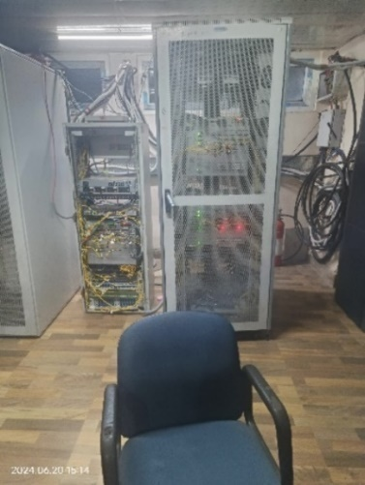 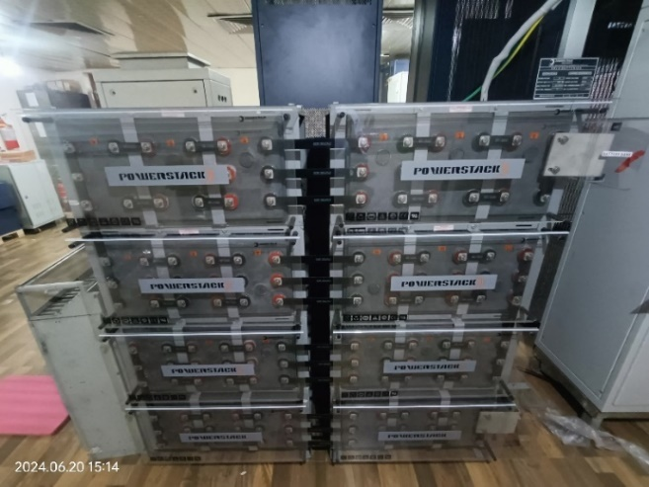

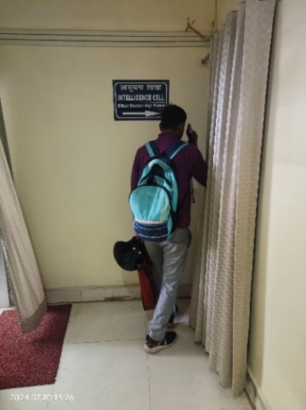 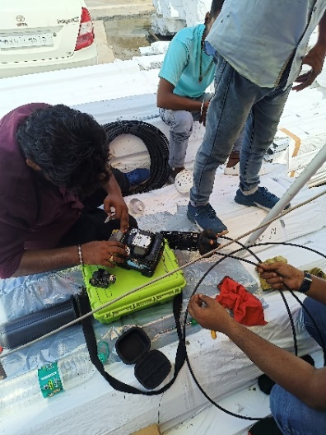 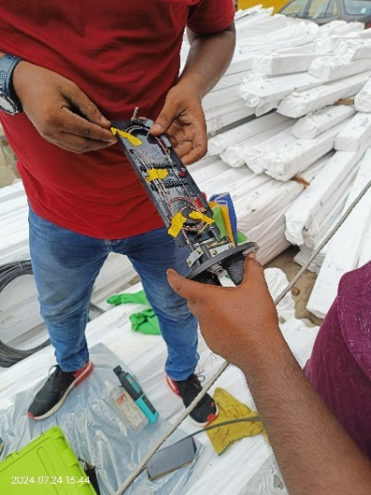

Figure 4.1 a) Telecom Server Room b) VRLA Batteries c) Intelligence Cell At CRPF, Patna, Bihar d) Fiber Splicing of KRIBHKO-Bihar Grid link e) Closure Box for Spliced fiber

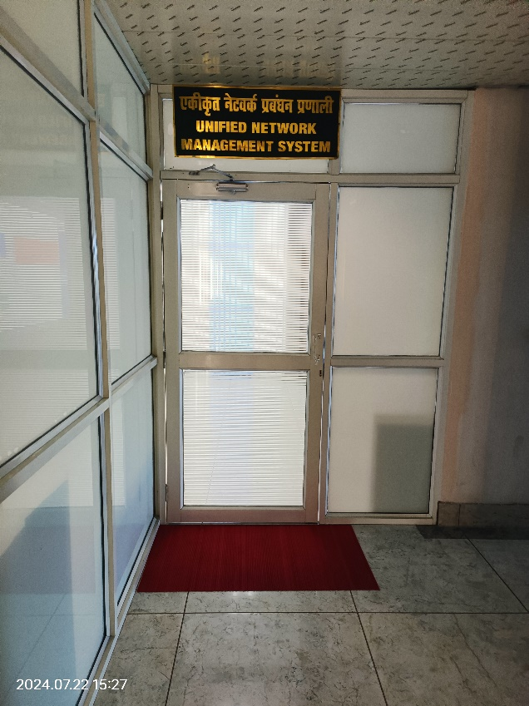 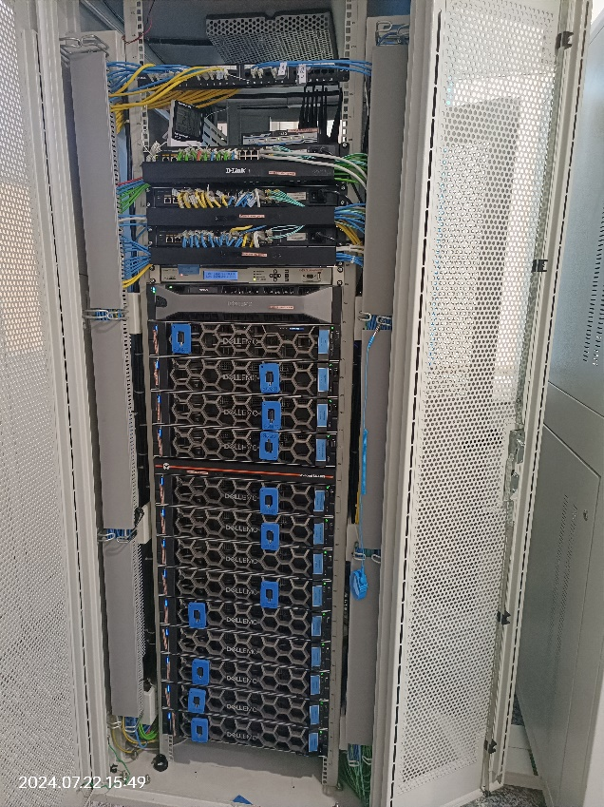

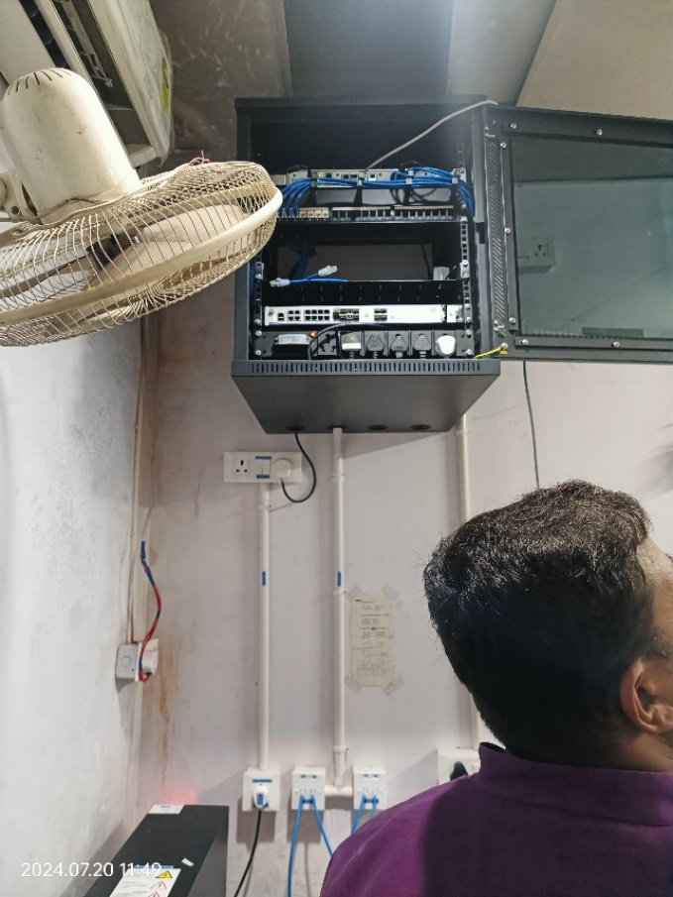 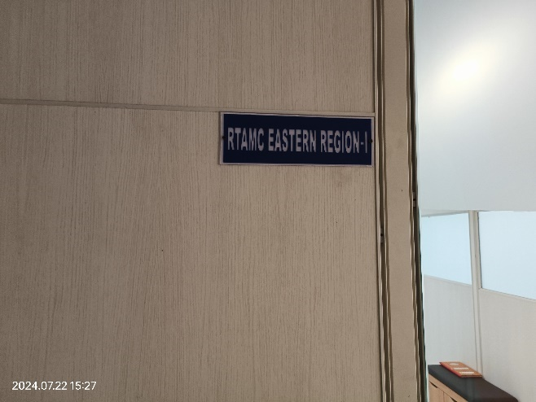

Figure 4.2 a) UNMS Monitoring Room b) UNMS Server room c) SMAC Chamber at ATS Headquarters Patna d) RTAMC ER-1 PGCIL Patna

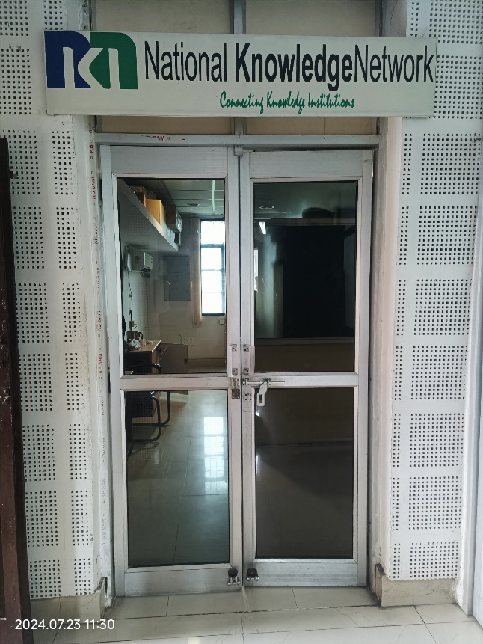 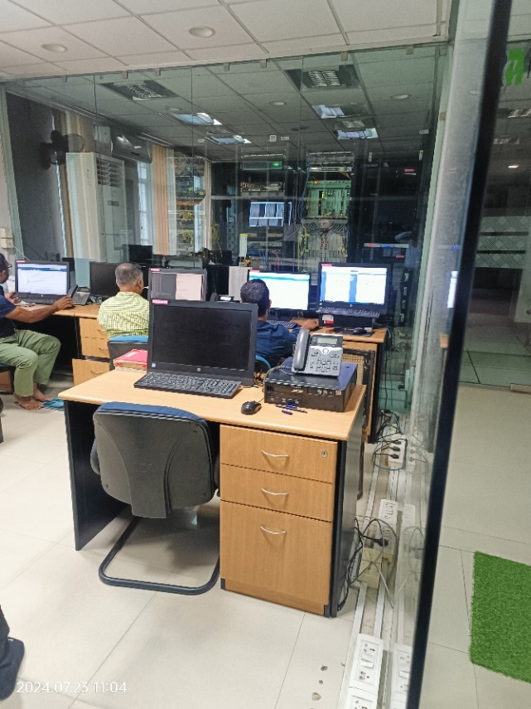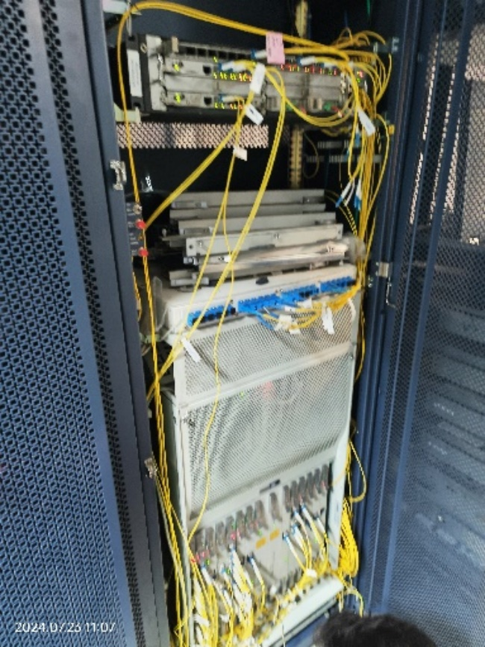 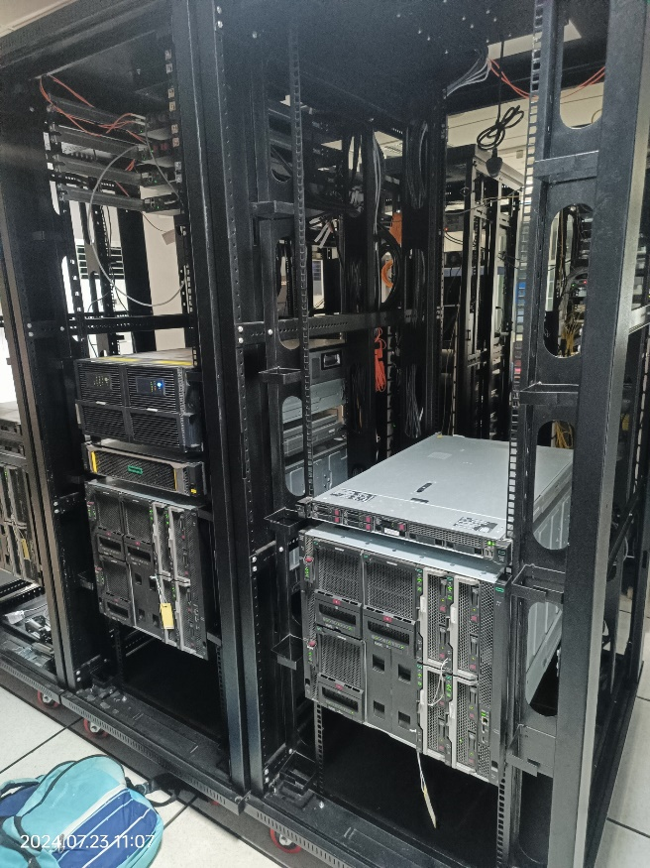

Figure 4.3 NIC Site a) National Knowledge Network Centre b) NIC Monitoring Room c) PGCIL racks at NIC (SDH) d) Routers and Devices

## UNMS

Unified Network Management System manages all the nodes, links, and devices throughout the network. It remotely monitors the links and the devices and constantly checks for any failure. PGCIL ER-I works as a data recovery centre (DR) which works when the data control centre (DC) server fails. DR has two main racks and two stand by racks each having one server rack and network rack. The officials check for the link or node failure and raises the ticket.

### Cygnet UNMS [12]

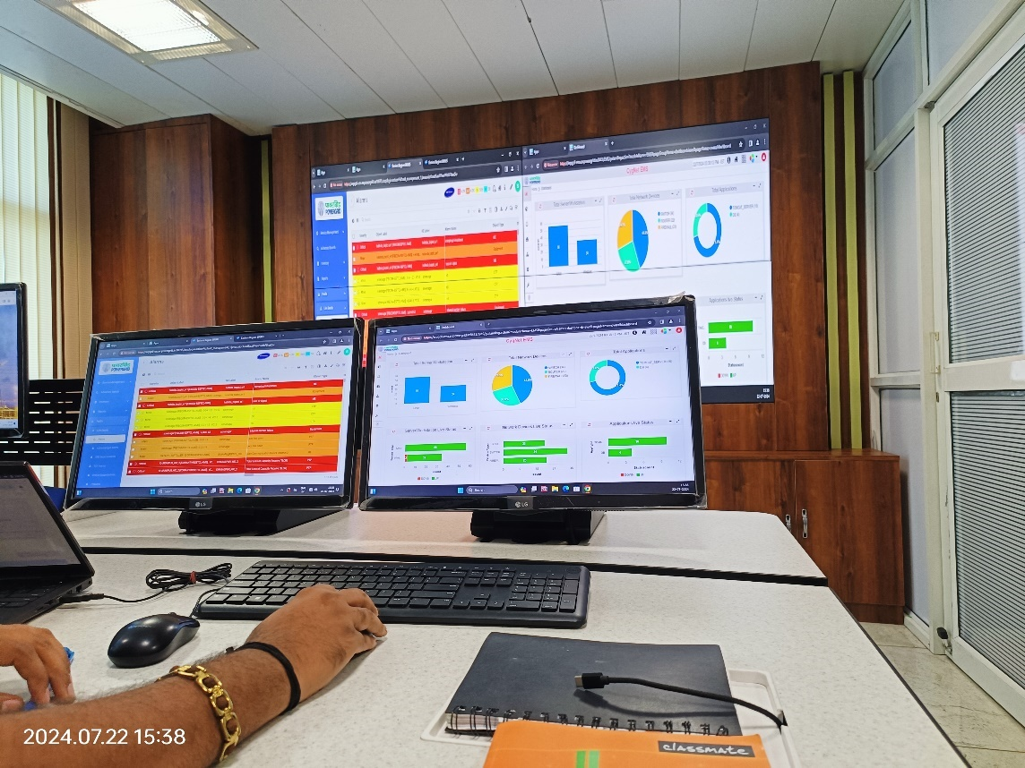

Figure 4.4 UNMS Monitoring Room at PGCIL ER-1

The capacity of the CygNet OSS solution package to effortlessly manage numerous technologies inside a sizable network is a key feature. Network Elements (NEs) such as DWDM, IP/MPS (Routers/Switches), and GPON, for instance, allow networks to be controlled uniformly without requiring switches. Built on the CygNet Service Management Platform (SMP), which includes Discovery/Network Inventory, it is an overlay of SMP that contains OSS functionality like Configuration Management, Fault Management (FMS), Root Cause Analysis/Service Impact Analysis (RCA/SIA), Performance Management (PMS), and Service Provisioning & Activation (SPAS). Because the SMP offers real-time visibility into network resources, it is possible to create, distribute, and ensure services quickly. Technical Order Orchestration System (TOMS/OOS), Trouble Ticketing, SLA Management and Reports/Dashboard for Transmission (SDH, DWDM) & IP/MPLS network are also provided in a tecnology agnostic manner, hiding complexities of the integration of disparate elements from end-users.

In addition to NMS for monitoring and managing network devices across locations, an Enterprise Management System with following key components shall be provided as an integrated solution with EMS to provide the Service Assurance functions in the NOC,

* Support capability for centralized monitoring and configuration of DWDM based Optical and IP/MPLS network through NOC
* Supports SNMPv1, v2 & v3 for integration with device/EMS NBI
* Supports CORBA, Web Services/SOAP, XML, CLI, CSV, Flat File (ASCII), FTP, Telnet, VML, WebRM, Custom for integration with device/EMS NBI
* Allows the user to zoom down to the port level of any given card /equipment.
* Centralized monitoring solution for all Network, IT infra & Servers.
* Provides Fault, Configuration & Performance management of the datacentre infrastructure and Network
* Monitors IP-SNMP enabled devices such as Routers, Switches, Cameras, Online UPS, etc.
* Integration with SLA & Contract Management system to supply KPI metrics like availability, utilisation in order to measure central SLA’s and calculate penalties.
* Help measuring SLA's as well as assist administrators to monitor network faults & performance degradations in order to reduce downtimes, increase availability and take proactive action to remediate & restore network services.

### UNMS Server Room Architecture

### 

PGCIL ER-I is a data recovery centre which has two main and two standby server and network rack. In the server rack we have Patch panel, LAN switches, GPS, NAS and many other devices whereas in the Network rack we have Patch panel, SAND box,External firewall,SAN storage etc.

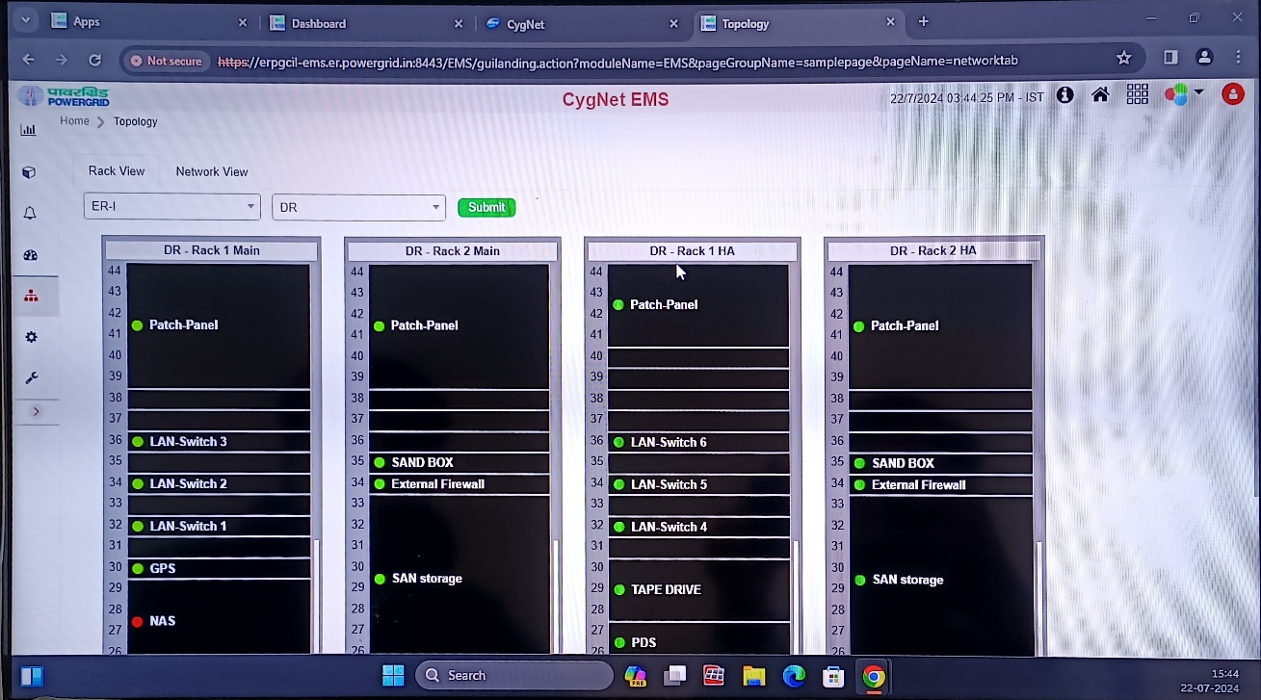

Figure 4.5 DR Server Room Architecture

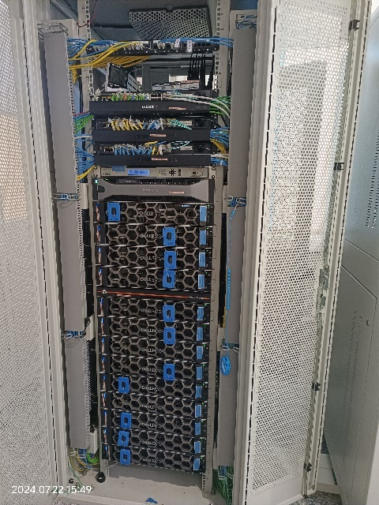 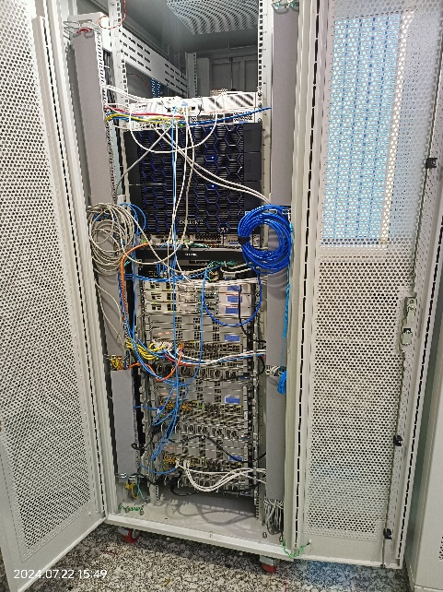

Figure 4.6 Server Rack Main b) Network Rack (Main)

### Network Topology

The network topology shows all the devices, links and the technology used in the path of the network. In ER-I and ER-II we use SDH and PDH technology to monitor all the link failures.

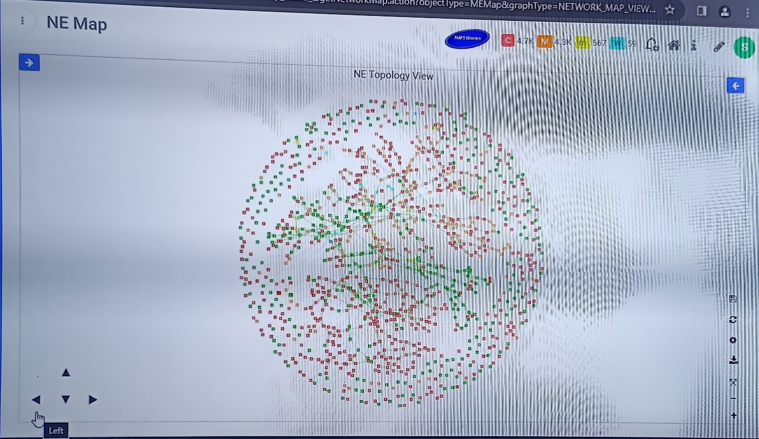

Figure 4.7 Network Topology view of ER-I and ER-II

Different layer rates and technologies are shown in different colours and thickness.

Layer Rates used are E1, STM-4, STM-16. STM-16 has the maximum thickness. E1 only supports 2Mbps.

Technologies used are SDH and PDH. PDH has max data rate of 2Mbps and is connected to SDH through E1. SDH has minimum data rate of 2 Mbps, it uses layer rate STM-4 and STM-16.

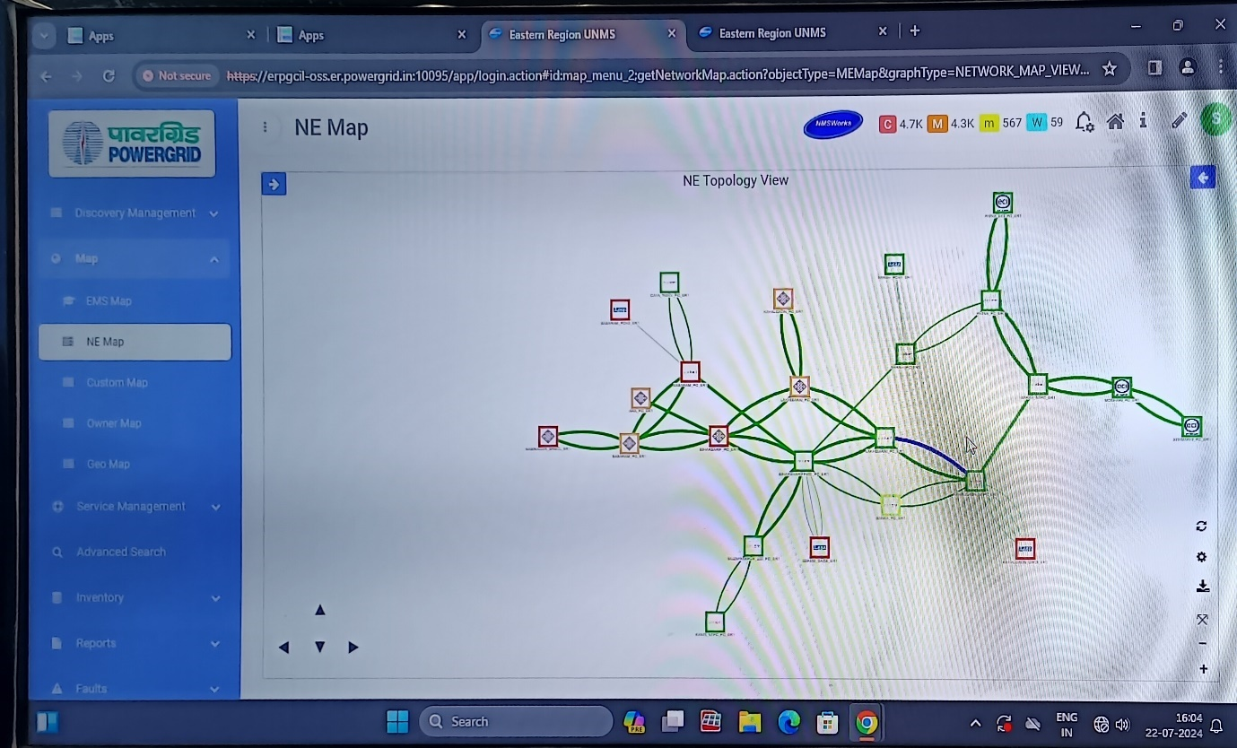

Figure 4.8 Network Topology View of RHQ

## NTAMC and RTAMC

For the purpose of providing centralized remote control and monitoring for POWERGRID substations spread geographically throughout India, NTAMC (National Transmission Asset Management Centre) was built. The primary control center, or NTAMC, is situated in Manesar, Gujarat, while the secondary control center, or BNTAMC, is situated in Bengaluru, Karnataka. Moreover, Regional Transmission Asset Management Centers, or RTAMCs, are included in every Regional Headquarters. Similar to how RTAMC of the SR-2 region is co-located with Backup NTAMC, RTAMC of the NR-1 region is co-located with Main NTAMC. Modern software systems, including some exclusive capabilities introduced for the first time in the power industry to handle the increasing competition of the Indian transmission sector, are installed in the control centers.

### FUNCTIONS OF NTAMC

**NTAMC**

* Monitoring of all system parameters
* Taking role of RTAMC under emergency conditions
* Cyber Security Operation Centre.

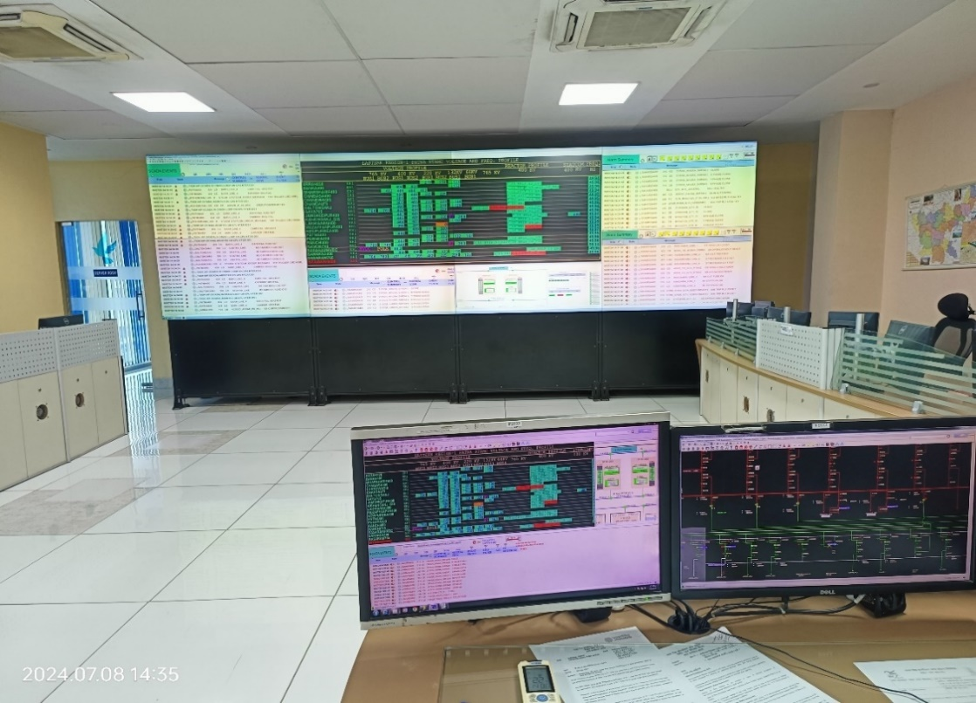

Figure 4.9 RTAMC ER-I PGCIL

**RTAMC**

* Control & Monitoring of all system parameters
* Coordination with load despatch centres

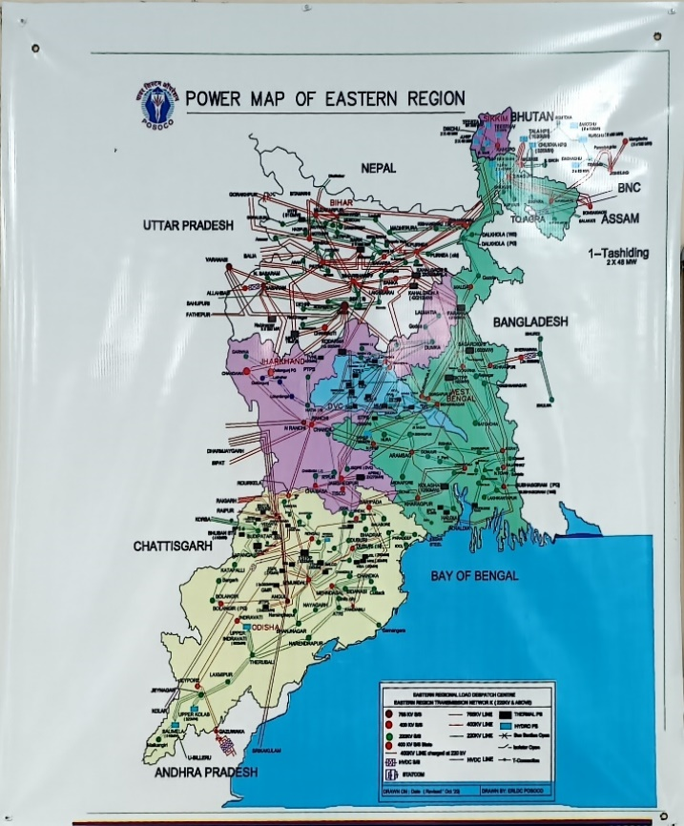

Figure 4.10 Power Map of Eastern Region

**Backup NTAMC**

* Disaster recovery
* Back up for performing all functions of NTAMC

### BENEFITS OF NTAMC SYSTEM

* Faster restoration in case of tripping through online diagnostics of real time parameters & disturbance record file acquisition.
* Avoiding consequential damage to the assets by early detection of alarm or defect.
* Real time visualization of Substation assets.
* To enhance the asset life by ensuring operation of equipment within rated parameters.
* Safe & Secured operations with minimum human intervention and interlocking applicability at multiple stages.

## SCADA [10]

In the telecom sector, Supervisory Control and Data Acquisition (SCADA) is a vital technology for controlling and monitoring intricate systems. It enables more effective network management and maintenance by providing real-time data from faraway locations. Typically, SCADA systems are composed of hardware and software elements that work together to gather and process data, generate alarms and alerts, and automate tasks. For telecom firms to guarantee uninterrupted network operation, minimize downtime, and enhance network security, this technology is essential. With the evolution of the telecommunications industry, SCADA systems will play a more significant role in helping businesses offer their clients dependable, superior services.

### Components of a SCADA System in Telecommunications: Hardware and Software

The two primary components of SCADA systems in the telecom sector are software and hardware. Together, the two parts offer the data and control capabilities needed for efficient network upkeep and management.

The hardware part of a SCADA system consists of sensors, PLCs, communication devices, and other apparatus that gathers data from remote locations and relays it back to the SCADA control center. Among the many factors that sensors are capable of measuring are temperature, humidity, pressure, and flow rate. PLCs are used to automate tasks like turning on or off pumps, compressors, and other devices based on sensor data. Communication devices are used to transfer data between remote sites and the control center.

The software component of a SCADA system is in charge of processing and presenting data gathered from distant locations. Usually, this software has a graphical user interface (GUI) that lets users see data, control equipment from a distance, and get warnings and alarms when specific parameters are reached. Additionally, the software has data storage features that let operators see any network problems and analyze trends.

A SCADA system's hardware and software components combine to offer a comprehensive solution for real-time monitoring and control of complex systems, facilitating effective network management and maintenance.

### Benefits of SCADA in Telecommunications: Enhancing Network Performance and Security

SCADA systems provide numerous advantages to the telecommunications industry, including improved network performance and security. Some of the key advantages of SCADA in telecommunications are as follows:

* **SCADA systems provide real-time data from remote sites** allowing operators to monitor the network and identify potential issues before they escalate into more severe issues. This decreases downtime while increasing network availability and reliability.
* **SCADA systems have the ability to automate processes**, reducing the need for manual intervention and increasing efficiency. For example, the system can automatically adjust the power supply or temperature in response to network changes.
* **SCADA systems enable operators to control devices remotely**, eliminating the need for physical access to remote sites. This reduces maintenance costs while also improving safety.
* **Security:**SCADA systems improve network security by restricting unauthorized users’ access and providing alerts and alarms for any suspicious activity.
* **Data Analytics:** SCADA systems are capable of storing and analyzing large amounts of data, providing valuable insights into network performance, and identifying areas for improvement.

### Implementation of SCADA in Telecommunications: Best Practices and Strategies

SCADA implementation in telecommunications can be a complex and difficult process. Consider the following best practices and strategies when implementing SCADA systems:

* **Define Clear Objectives**
* **Conduct a Needs Assessment**
* **Select the Correct Hardware and Software**
* **Create a Robust Security Plan**
* **Train Personnel**
* **Establish Maintenance Procedures**

***CHAPTER 5***

# Smart Grid and The Future

## Smart Grid Technology [11]

Traditional grid methods transfer electricity produced at a central power plant, which is a straightforward task. Voltage transformers, which progressively raise and lower voltage levels while supplying energy to end customers, cause this. On the other hand, smart grids carry out all of the traditional tasks with the added benefit of being able to remotely monitor every activity for better and faster performance.

**Six Smart Grid Technology Applications Leading the Change.**

### Advanced Metering Infrastructure

Another name for this is AMI. It's just using technology, such as smart meters, to facilitate information sharing between energy companies and their customers. The time, amount, and appropriate pricing of consumption are the main topics of this information. When compared to traditional grid technology, it makes smart grids capable of a great deal more functionality.

These functions include but are not limited to:

* Remote consumption control
* Time-based pricing
* Consumption forecast
* Fault and outage detection
* Remote connection and disconnection of users
* Theft detection and loss measurements
* Effective cash collection and debt management

### **Demand Response**

Programs for demand response (DR) are newer and developing uses of demand-side management (DSM). Applications that help lower wholesale energy prices and their volatility, as well as those that enhance grid dependability by offering services like frequency management, spinning reserves, and operating reserves, are a few examples.   
• **Price-based demand response** (DR), in which consumers maximize their power usage and reduce their costs by adjusting their consumption in response to the time-variant pricing set by their utility agencies.  
• **Incentive-based demand reduction** (DR), in which the advantages are amplified by offering an incentive to persuade customers to alter their demand consumption patterns.

By enabling consumers to change or cut back on their electricity use during peak hours through the aforementioned programs, distributed renewable energy (DR) gives users a significant say in how electric networks function in an effort to maintain a balance between supply and demand.

### Electric Vehicles (EVs)

The best way to address the problem of global warming is via EVs. The advent of plug-in electric vehicles presents a multitude of opportunities and challenges in terms of smart grid technologies for maintaining power networks. The grid will be put in jeopardy if EVs are introduced to the grids as regular loads because there won't be any room for load variable flexibility.   
By functioning as distributed storage resources (V2G) that support ancillary services like frequency management, peak-shaving power for the system, or the integration of variable renewable resources, EVs can help advance the sustainability of smart grids.

### Wide-Area Situational Awareness

This is the application of a group of technologies intended to enhance the monitoring of the electricity system over wide geographic areas, thereby giving grid operators a comprehensive and dynamic view of the grid's operation. According to SELinc, WASA systems give engineers and operators the appropriate information at the appropriate moment for effective power system analysis and operation. Here, understanding and optimizing the smart grid's performance to maximize reliability and foresee where adjustments are needed before issues arise, is still the ultimate objective.

* Real-time monitoring
* Prediction of future disturbances

### Distributed Energy Resources and Storage

Smaller energy sources or generation units that are situated on the customer side of the electrical generation meter are referred to as distributed energy resources, or DERs, and are a subset of distributed generation. Instead of coming from a centralized system, energy is produced locally, primarily from renewable sources. Wind generators and rooftop solar photovoltaic systems are a couple of examples. However distributed energy resource (DER) storage systems store dispersed energy for future consumption. Bi-directional inverters and DC-charged batteries are the two tools used to accomplish this. It aids in balancing the production, supply, and demand of energy. Other important characteristics are:

* Peak shaving
* Load shifting
* Voltage regulation
* Renewable integration
* Back-up power

### Distribution Grid Management

All of the hardware required for distributing energy, such as wires, poles, transformers, etc., is included in a distribution grid. Having a system "capable of collecting, organising, displaying and analysing real-time or near real-time electric distribution system information" when required is key to smart grid distribution grid management. Grid operators can also use this technology to plan and schedule complicated jobs to maximize energy flow, fulfill goals, avoid breakdowns, and boost efficiency. Additionally, it may collaborate seamlessly with other systems to produce a unified perspective of dispersed processes. Smart grid technologies are designed to be intelligent; they can predict errors that can subsequently be avoided, reduce costs where they can, and provide customers with the best value when required.

## Smart Grid Knowledge Centre

In order to raise awareness and develop capacity regarding the deployment of smart grid technology among utilities and other power sector stakeholders, the Smart Grid Knowledge Center (SGKC) was founded in partnership with the Ministry of Power. The Honourable Central Energy & New and Renewable Energy Minister officially opened the center on September 19, 2018. It has models that utilize Smart Grid technologies and cutting-edge training resources to offer practical instruction in this area. More than 500 specialists in the power industry, both domestically and internationally, have already received training from the center.[25]

The existing infrastructure infrastructure at SGKC provides for capacity building and hands-on training on the following functions:

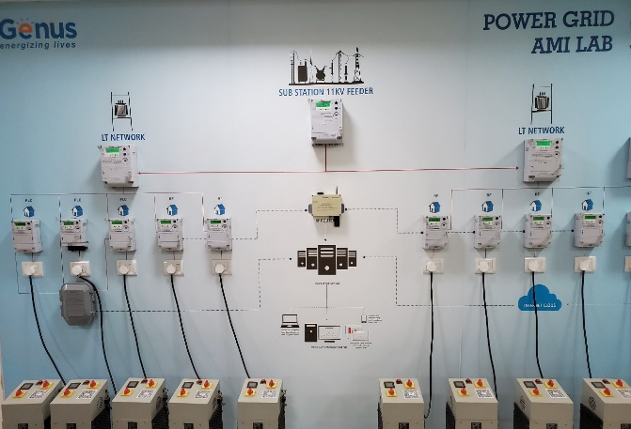 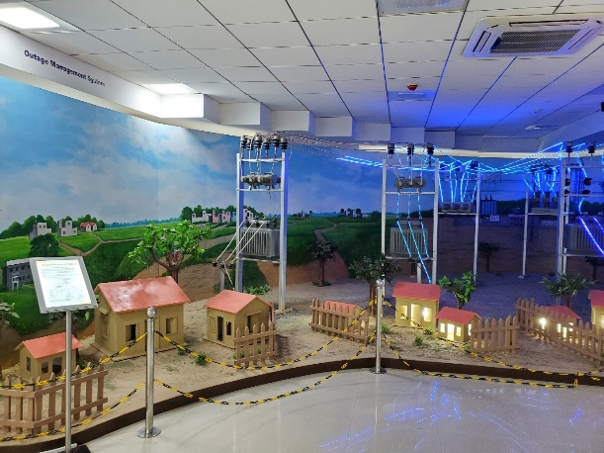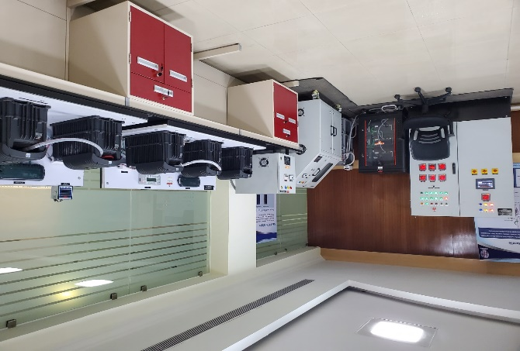 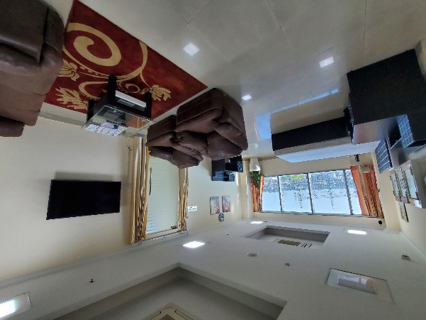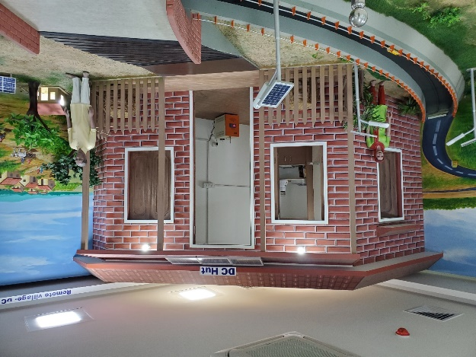 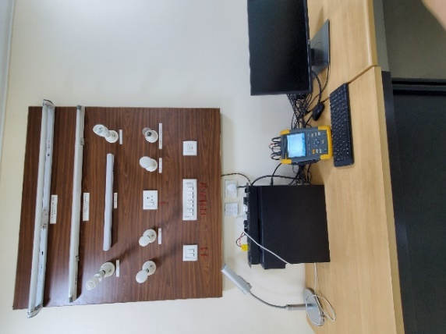

Figure 5.1 a) Advanced Measurement Infrastructure Lab PowerGrid [19] b) Idle Call/ Outage Management System [20] c) AC Micro-Grid [21]d) Smart Home [22] e) DC Hut [23] f) Power Quality test [24]

### Advanced Measurement Infrastructure [13]

The existing infrastructure infrastructure at SGKC provides for capacity building and hands-on training on the following functions:

Functions installed and displayed are as follows: :

* Meter Data Acquisition System (MDAS)
* Meter Data Management System (MDMS)
* Smart Prepaid/Postpaid Meter
* Remote Load Limiting for Peak Load Management (DSM)
* tamper/alert detection

### Idle Call/Outage Management System [14]

An outage management system's goals are to increase power supply availability and dependability, offer information and customer satisfaction, and provide early warning for preventative maintenance to avert failures and outages. Displayed are operational real-world versions of Automatic Repeaters, Sectioners, Distribution Transformer Monitoring Units, and Route Fault Indicators (FPIs).

### AC Micro-Grid [18]

A real life working model of AC microgrid has been established incorporating three solar PV technologies (monocrystalline, polycrystalline and thin film), wind turbine, battery energy storage (lead acid and lithium ion) as energy sources.

**The installed system helps to understand the following**

* Comparison of functional performance of three different solar PV technologies
* Operation of microgrid in grid-tie and off-grid mode
* Functional behaviour and performance of lead acid and lithium ion battery energy storage systems (BESS)

### Smart Home/Home Energy Management System [15]

A smart home energy management system gives the user total control over how their appliances operate and how much power they use, as well as how much electricity, energy, and bill money they require. The devices can be programmed to operate on a schedule.

The Manesar smart home system includes extra features like an intrusion alarm, gas and fire alarms, artificial intelligence integration for all devices, and more, depending on the daily tariff. Every installed function is accessible on a mobile device and may be used from any location with an internet connection.

### Direct Current/DC Micro Grid [16]

Remote locations without access to or with very unstable electrical distribution networks can receive power via DC microgrids. DC equipment is directly powered by DC electricity produced by solar panels.

### Power Quality [17]

With the help of power quality analyszr, current vibrations/harmonics and distortions produced by various electrical and electronic devices, especially various types of home lighting equipment, can be analyzed.

**In addition to the above existing infrastructure, procurement of the following modules is in progress:**

* Smart Grid Emulator System
* EV Charging Emulator and EV/EVSE Testing System
* Power Hardware in Loop (Phil) System
* Power Distribution Network Planning Simulator
* Real-time emulation of feeder automation using autoclosure, Smart Load Break Switch (SLBS), Smart Fault Isolation Device (SFID), etc.

# REFERENCES

1. <https://www.powergrid.in/index.php/en/telecom>
2. <https://www.powergrid.in/sites/default/files/common_type/Powertel_Brochure_1.pdf>
3. <https://www.coherent.com/news/glossary/optical-fibers>
4. <https://www.linkedin.com/pulse/what-opgw-rhonda-tian/>
5. <https://www.linkedin.com/pulse/difference-between-single-mode-fiber-multi-mode-shuxuan-judy-zhang/>
6. <https://www.thorlabs.com/newgrouppage9.cfm?objectgroup_id=10759>
7. <https://community.fs.com/article/understanding-otdr-dead-zone-specifications.html>
8. <https://www.mvasite.mvapower.com/index.php/t-d/fiber-optic-cable/opgw/aluminum-tube-opgw>
9. <https://www.powergrid.in/en/ntamc-overview>
10. <https://www.scadainfo.com/scada-in-telecommunications/>
11. <https://www.hivepower.tech/blog/smart-grid-technology-changing-the-power-industry>
12. <https://www.nmsworks.co.in/solution/Solution%20Page%20-15.html>
13. <https://www.powergrid.in/en/smart-energy#1>
14. <https://www.powergrid.in/en/smart-energy#2>
15. <https://www.powergrid.in/en/smart-energy#3>
16. <https://www.powergrid.in/en/smart-energy#6>
17. <https://www.powergrid.in/en/smart-energy#5>
18. <https://www.powergrid.in/en/smart-energy#7>
19. <https://www.powergrid.in/sites/default/files/inline-images/ami.jpg>
20. <https://www.powergrid.in/sites/default/files/inline-images/oms.jpg>
21. <https://www.powergrid.in/sites/default/files/inline-images/amg.jpg>
22. <https://www.powergrid.in/sites/default/files/inline-images/shems.jpg>
23. <https://www.powergrid.in/sites/default/files/inline-images/dcmg.jpg>
24. <https://www.powergrid.in/sites/default/files/inline-images/pg.jpg>
25. <https://www.powergrid.in/en/smart-energy>